Tutorial -1

Vaibhav Singh (RA231100301067)

OUTPUT:

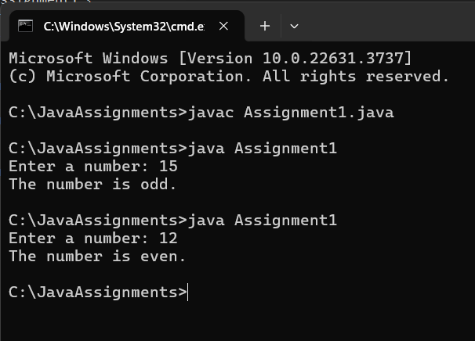

2. CODE: AGE VERIFICATION

OUTPUT :

3. CODE : VENDINNG MACHINE

OUTPUT:

4.CODE : TEMPERATURE CHECK

OUTPUT :

CODE : POSITIVE,NEGATIVE OR ZERO

OUTPUT :

6.CODE : GRADING SYSTEM

OUTPUT :

7. CODE : SIMPLE CALCULATOR

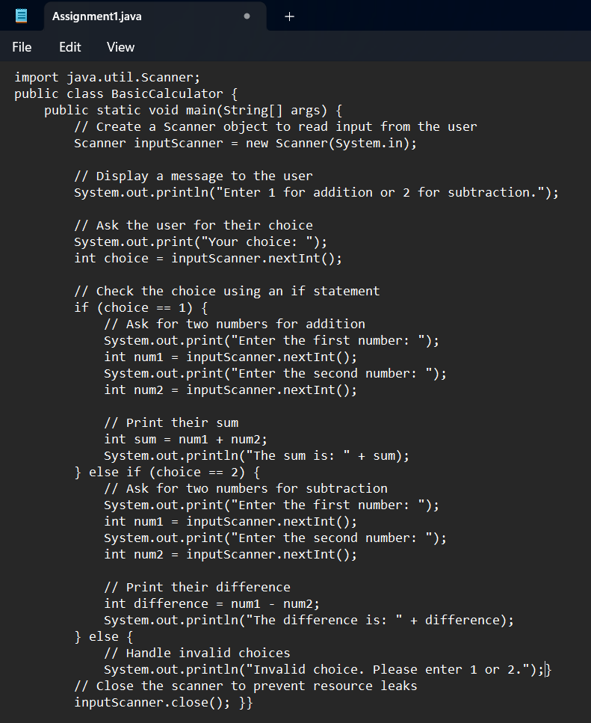

OUTPUT :

8. CODE : LEAP YEAR

OUTPUT :

